- Write a SELECT statement that returns all columns from the Vendors table inner-joined with the Invoices table.
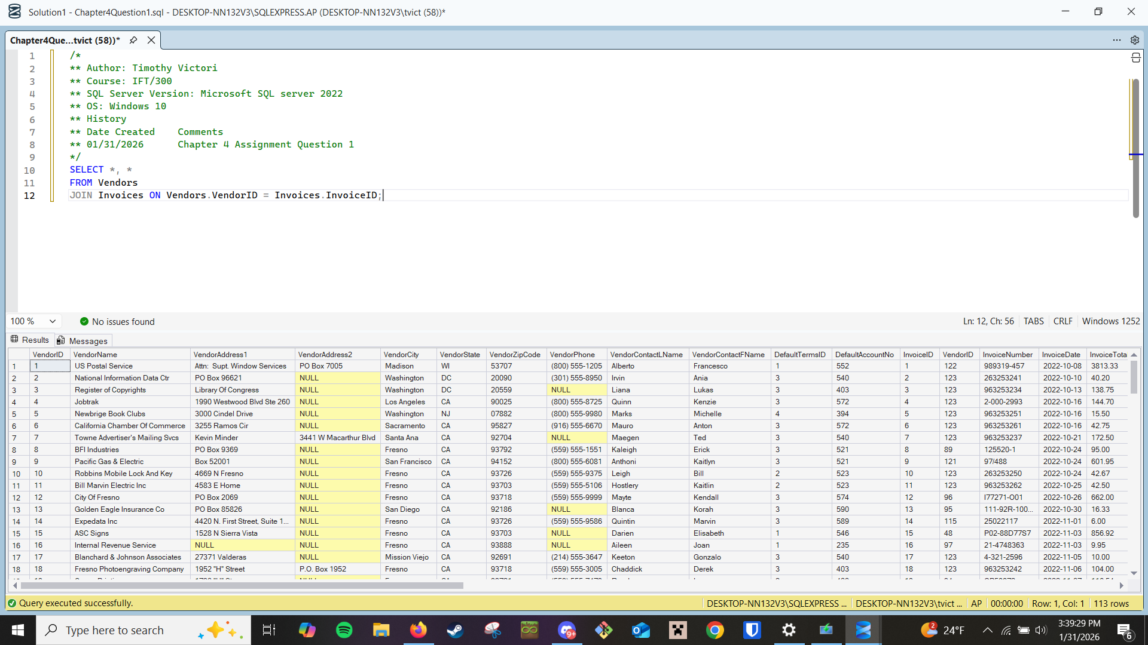
- Write a SELECT statement that returns four columns:
VendorName From the Vendors table
InvoiceNumber From the Invoices table
InvoiceDate From the Invoices table
Balance InvoiceTotal minus the sum of PaymentTotal and CreditTotal
The result set should have one row for each invoice with a non-zero balance. Sort the result set by VendorName in ascending order.
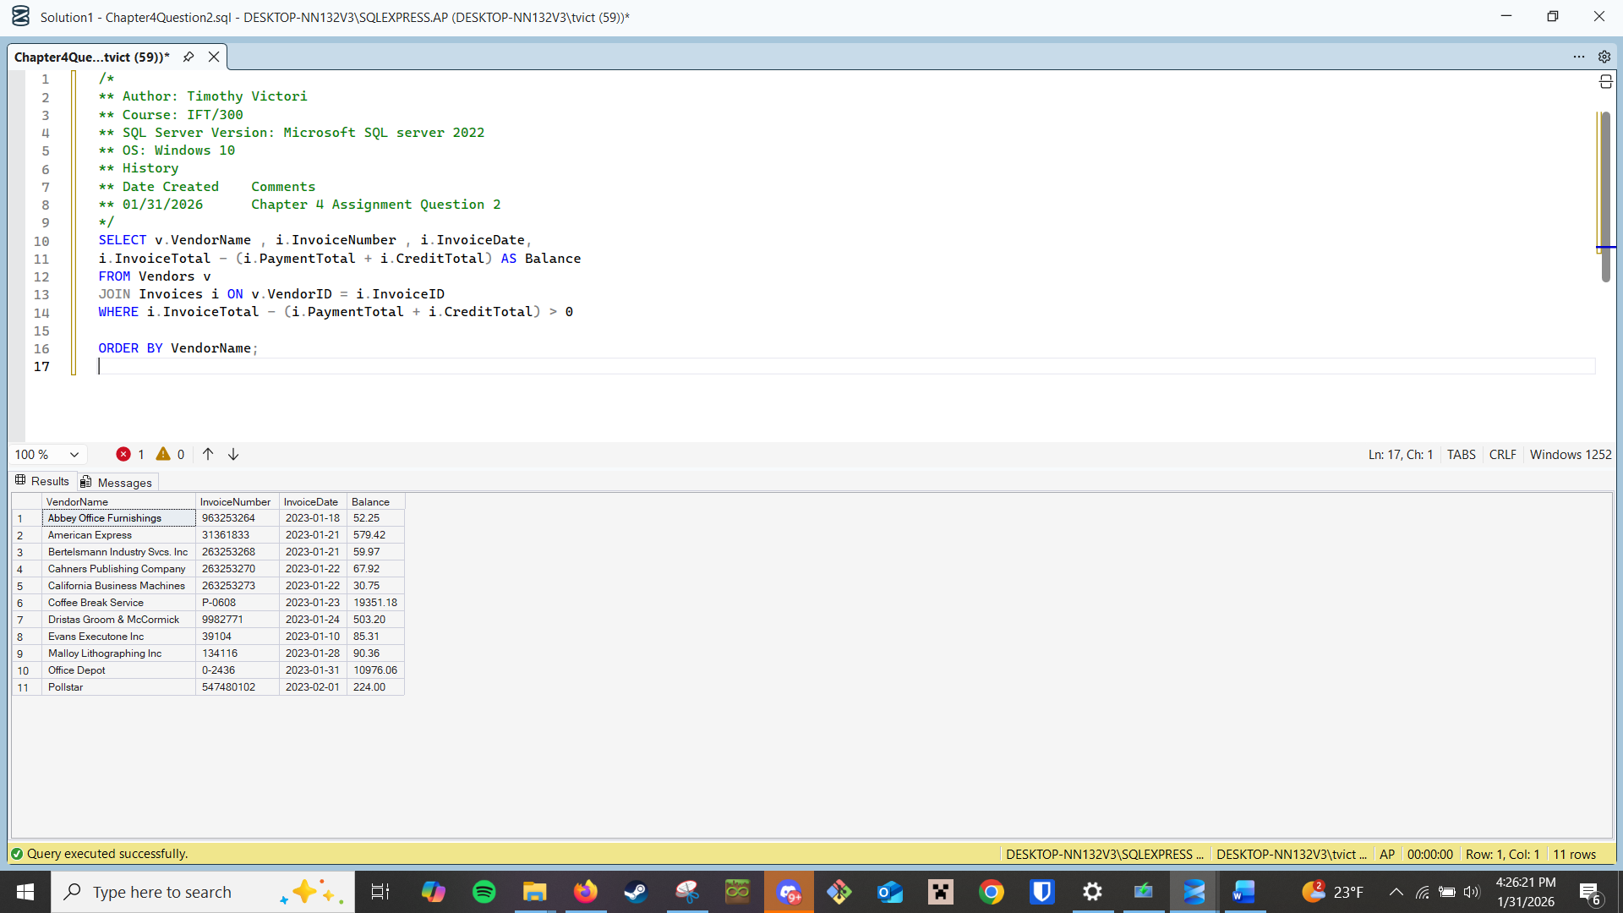
- Write a SELECT statement that returns three columns:
VendorName From the Vendors table
DefaultAccountNo From the Vendors table
AccountDescription From the GLAccounts table
The result set should have one row for each vendor, with the account number and account description for that vendor’s default account number.
